Exploratory Data Analysis (EDA) Using Matplotlib
Customer Churn Prediction – Documentation

1. Objective
The objective of this Exploratory Data Analysis (EDA) is to understand customer churn behaviour by visualising patterns, trends, and relationships present in a telecom customer dataset using Matplotlib.
EDA plays a critical role in identifying the factors that influence whether a customer continues or leaves the service, thereby forming a strong and reliable foundation for subsequent predictive modelling and machine learning development.

2. Tools and Technologies Used
- Python – Core programming language used for analysis
- Pandas – Loading, cleaning, and transforming the dataset
- Matplotlib – Creating visualizations for data understanding
- OS Module – Managing output directories for saving plots

3. Dataset Description
The Telco Customer Churn dataset contains 7,043 customer records, where each row represents an individual customer and their service usage details.
Key Columns from the Original Dataset
- Churn – Target variable indicating whether the customer left the service
- tenure – Number of months the customer has stayed
- MonthlyCharges – Monthly billing amount
- Contract – Type of contract (Month-to-month, One year, Two year)
- InternetService – Internet service type
- SeniorCitizen – Indicator for senior citizen customers
- gender – Customer gender
- PaymentMethod, PaperlessBilling, PhoneService, MultipleLines – Billing and service attributes
- OnlineSecurity, OnlineBackup, DeviceProtection, TechSupport, Streaming services – Value-added services
Before visualisation, the dataset was validated for structure, data types, and completeness to ensure reliable analysis.

4. Synthetic Feature Augmentation
To demonstrate advanced segmentation and multi-dimensional visualization techniques, additional features were introduced using controlled random assignment.
Synthetic Features Added
- Region – Customer geographic segment
- Device_Type – Type of device used
- Network_Type – Network generation (2G–5G)
- SIM_Provider – Telecom service provider
- Usage_Pattern – Low, Medium, High usage behaviour
These features simulate real-world telecom attributes and are used for learning, segmentation analysis, and enhanced visualisation, not for drawing real-world conclusions.

5. Visualisations Using Core Dataset Attributes
5.1 Churn Distribution
- Graph Used: Bar Chart (Percentage)
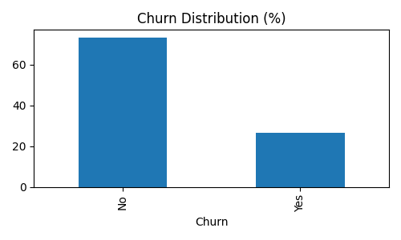
Observation:
Most customers remain with the service, but a significant portion has churned.
Insight:
The dataset is imbalanced, confirming churn as a serious business concern and requiring careful evaluation metrics during modeling.

5.2 Tenure vs Churn
- Graph Used: Box Plot
Observation:
Customers with lower tenure show higher churn, while long-term customers remain stable.
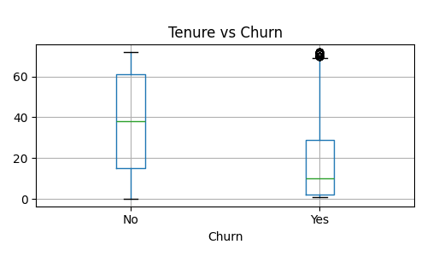

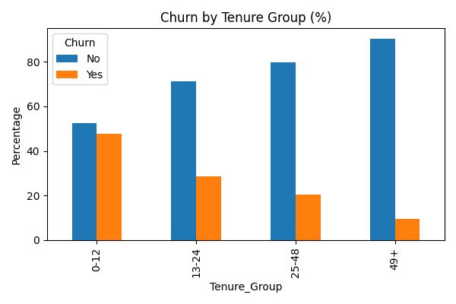

Insight:
Tenure is a strong indicator of customer loyalty. Early-stage customers require focused engagement.

5.3 Monthly Charges vs Churn
- Graph Used: Box Plot
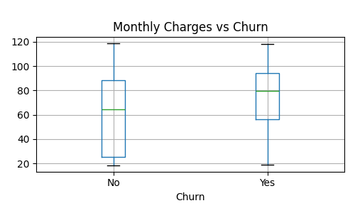
Observation:
Churned customers tend to have higher monthly charges.
Insight:
Pricing sensitivity plays a major role in churn, indicating potential dissatisfaction with cost-to-value ratio.

5.4 Contract Type vs Churn
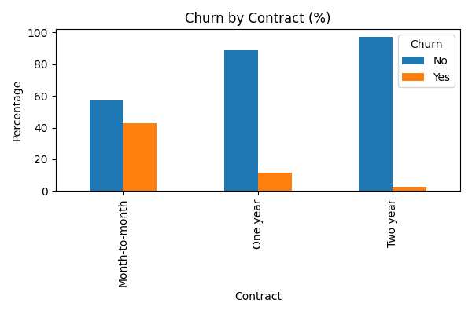
- Graph Used: Bar Chart (Percentage)

Observation:
Month-to-month contracts have the highest churn, while long-term contracts show lower churn.
Insight:
Encouraging long-term contracts can significantly improve customer retention.

5.5 Internet, Phone, and Billing Services
- Graphs Used: Bar Charts
Observation:
Churn exists across all service types, including phone service, multiple lines, and paperless billing.
Insight:
Churn is influenced more by pricing, contract type, and service quality rather than basic service availability.

5.6 Value-Added Services Analysis
- ServicesAnalyzed: OnlineSecurity, OnlineBackup, DeviceProtection, TechSupport, StreamingTV, StreamingMovies
Observation:
Customers without value-added services exhibit higher churn.
Insight:
Bundling value-added services can improve customer satisfaction and reduce churn risk.

6. Demographic-Based Visualisations
6.1 Gender-wise Churn
- Graph Used: Bar Chart (Percentage)

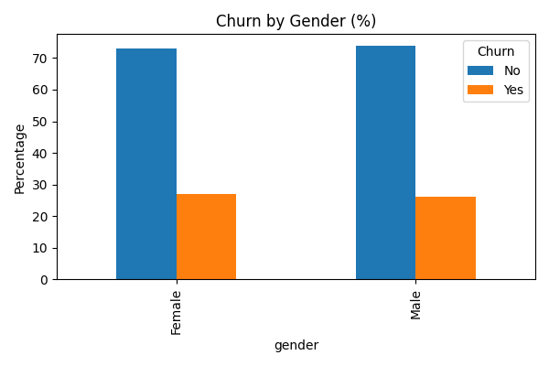
Observation:
Both male and female customers contribute to churn at similar levels.

Insight:
Gender alone is not a strong churn driver but is useful when combined with other factors.

6.2 Senior Citizen vs Churn
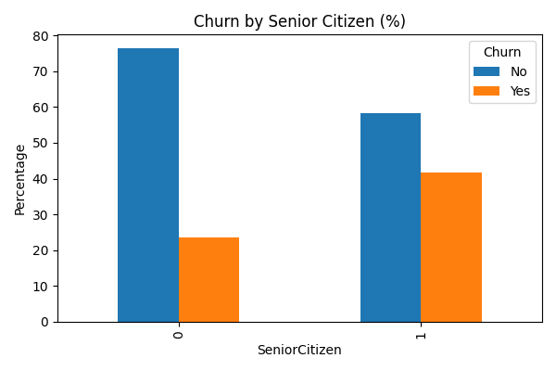
- Graph Used: Bar Chart

Observation:
Senior citizens show a distinct churn pattern compared to non-senior customers.
Insight:
Age-based segmentation is essential for designing targeted retention strategies.

6.3 Churn Among Senior Citizens by Gender
- Graph Used: Bar Chart (Count-based)
Observation:
Both senior male and senior female customers churn, with noticeable count differences.
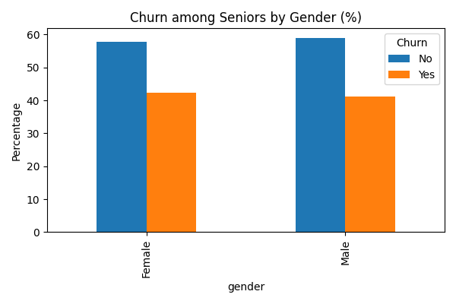
Insight:
Count-based visualization provides clear visibility into churn contribution without percentage distortion.

7. Visualisations Using Synthetic Features
7.1 Churn by Region
- Graph Used: Bar Chart
Observation:
Churn appears evenly distributed across regions.
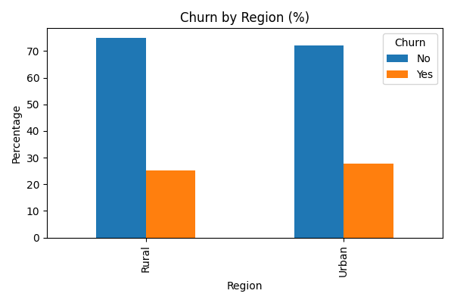
Insight:
Demonstrates geographic segmentation; no real-world conclusions are drawn due to synthetic nature.

7.2 Churn by Device, Network, SIM Provider
- Graphs Used: Bar Charts
Observation:
Churn is present across all device types, network generations, and providers.
Insight:
These analyses simulate real telecom scenarios and demonstrate multi-segment churn evaluation.

7.3 Multi-Dimensional Combinations
- Gender + SIM Provider
- Senior Citizen + Network Type
- Senior Citizen + SIM Provider

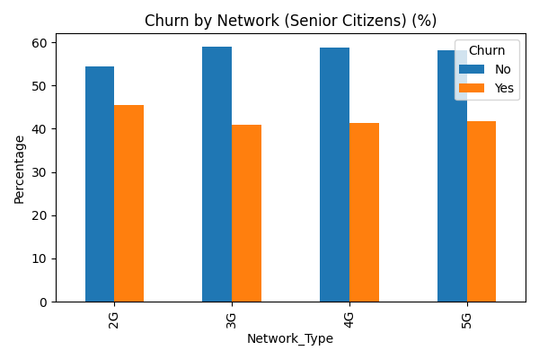
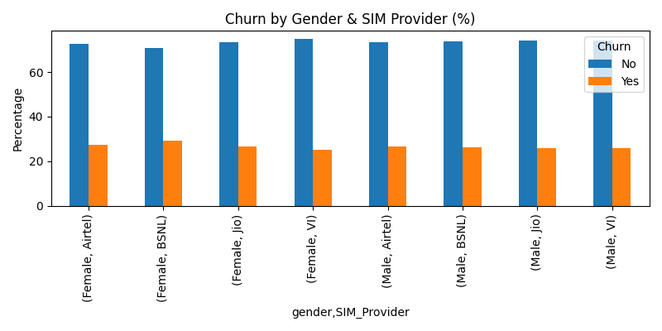
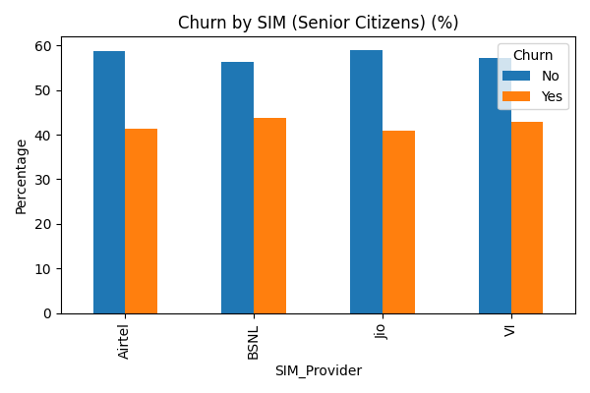

Insight:
Combining demographic and service attributes helps identify high-risk customer segments more effectively.

8. Correlation Analysis
- Graph Used: Heatmap
Features Analyzed: tenure, MonthlyCharges, SeniorCitizen
Observation:
- Tenure shows a negative relationship with churn
- Monthly charges show a positive relationship
- Senior citizen status influences churn

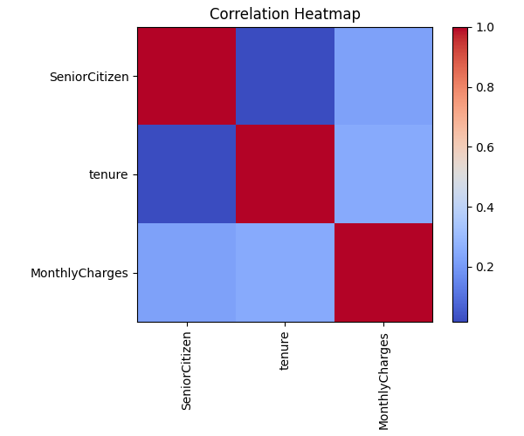
Insight:
Correlation analysis supports feature selection before model development.

9. Key Learnings
- Tenure, contract type, and pricing are the strongest churn drivers
- Early-stage customers and senior citizens require focused retention strategies
- Value-added services reduce churn risk
- Synthetic features enable advanced EDA learning
- Structured visualisation improves interpretability and confidence

10. Conclusion
This EDA successfully explored customer churn using a structured, multi-dimensional visualisation approach. By combining original dataset attributes with synthetic features, the analysis provided meaningful insights into customer behaviour, service usage, and churn drivers. The findings establish a strong foundation for feature engineering and machine learning model development, while clearly demonstrating professional EDA practices.

